



A Peek at Our Week

Week of August 1-5, 2016

**Ah-“Mason” Happenings in the Fifth Grade**

Week of April 16-20



Follow our school on Twitter @HillCityHawks.

Dear Parents,

Welcome back! We hope everyone had a restful spring break. It is hard to believe that this school year is almost over! With that being said, we are still actively learning and reviewing skills. We have several upcoming events, so please make sure you are aware of these dates.

Hill City will be hosting our first Fine Arts Night on April 27th, and we would all love for you to attend while we recognize our talented Hawks.

Warm regards,

Fifth Grade Teachers

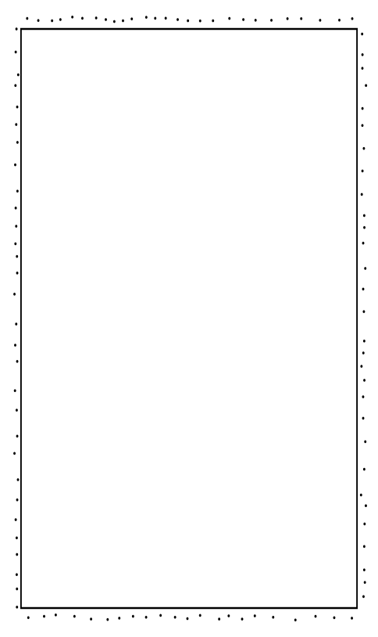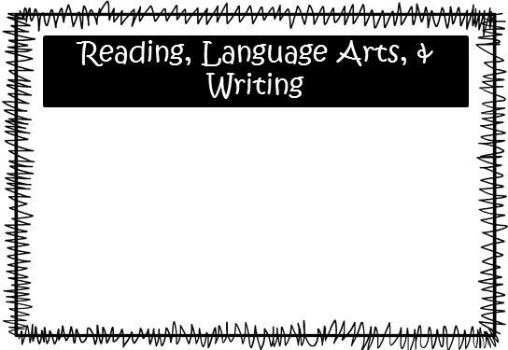

We will continue to review previous learned reading and writing skills, as well as, work on building our reading stamina through independent reading. Students will continue to work on analyzing and interpreting poetry and to respond to narrative constructed responses.

Things to Know

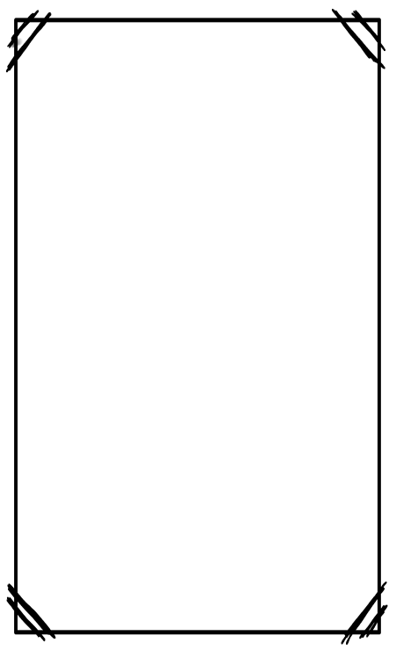

Upcoming Events:

* April 27th: Fine Arts Night, 6:00
* May 14th: Parent Academy Night
* May 22nd: 5th Grade Field Day
* May 24th: End of the Year Celebration & 5th Grade Awards

Email Addresses:

[Amandalo@pickenscountyschools.org](mailto:Amandalo@pickenscountyschools.org)

[Ashleypatterson@pickenscountyschools.org](mailto:Ashleypatterson@pickenscountyschools.org)

Brandimcentire@pickenscountyschools.org

[Carolsmith@pickenscountyschools.org](mailto:Carolsmith@pickenscountyschools.org)

Jenniferwilds@pickenscountyschools.org

Science: Mrs. Lo’s students will be discussing physical and chemical change. Mrs. McEntire’s students will be studying chemical change.

Social Studies: Students will finish their studies of the 1975-Present Day Unit and will test over the material on Friday, April 20th.

**Smith:** Students will continue to work on volume and the coordinate system. Students will also begin a unit on converting measurement.

**McEntire:** Students will begin reviewing skills. Also, they will begin their studies of algebra and data.

Math